Scottish Biometrics Commissioner

eRDM File Plan

Version 2.0 January 2023

Safeguarding our biometric future

Status control

Version | Date | Status | Author | Reason for amendment
1.0 | 21 July 2021 | Initial Final | Brian Plastow
1.1 | August 2022 | Draft | Cheryl Glen | - Reformatted the document to follow corporate SBC style  - Updated table – Main Records Folders
2.0 | January 2023 | Final | Cheryl Glen | - Updated text throughout document  - Updated table – Main Records Folders

Introduction
The purpose of this document is to set out a roadmap listing the different records to be maintained by the office of the Scottish Biometrics Commissioner. This File Plan list different records maintained by function. Understanding the File Plan will assist users in knowing where to file and retrieve the records needed to complete tasks.

The life cycle of a Record
Records follow a natural life cycle. Upon creation, records should be classified according to function so that they can be filed in a digital record keeping system and retrieved where necessary. Records will not be retained indefinitely and will follow pre-determined disposition in accordance with Scottish Government records management policies for eRDM. The life cycle is illustrated as follows:

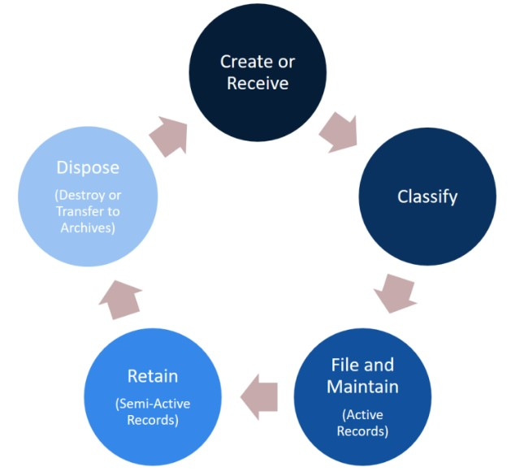

Function-based File Plans
Classifying records by function provides the best method to organise business records. Function-based file plans organise records based directly on the work that an office performs to fulfil its functions. Instead of organising records by what they are about (subject- or topic-based file plans), or who created them (position-based file plans), function-based file plans answer the fundamental question of why records are created and used by classifying them based on work processes. Function-based file plans are also stable and long-lasting. Subjects and positions can change frequently, but what an office does (its functions) generally stay the same over time.

eRDM File Plan
The schematic on the following page sets out the architecture for the File Plan for the Scottish Biometrics Commissioner within eRDM and a document naming convention. This has since been adapted by staff based on experience of what works best in practice.

Excluded data
The Scottish Biometrics Commissioner when conducting audits, inspections, or reviews of biometric data records held by one of the bodies to whom the Commissioner’s jurisdiction extends will not under any circumstances replicate any personal biometric data onto eRDM. Where review notes are taken as part of an audit, review, or inspection of such bodies, or as part of the investigation of a complaint relating to the Code of Practice, those notes will be destroyed immediately once the factual accuracy of the content of any report has been agreed with relevant stakeholders and our findings report published.

Conclusion
The File Plan is designed in such a way that it will remain relevant in future. The File Plan will avoid the proper names of current office holders. The File Plan will be reviewed at least once per year to make sure that all office functions and activities are covered and accurate. An authoritative version of the File Plan will also be stored for ease of reference.

Main Record Folders | 1. Strategic Planning | 2. Corporate functions | 3. Operational functions
Sub – Files under main folder | - Strategic plans  - Business plans  - Annual reports  - Annual accounts financial documentation  - Code of Practice  - Assessment Framework  - Governance  - Legal  - Certificate of Assurance Statements  - Budget bids  - Other parliamentary submissions  - Quarterly newsletters  - News releases | - Budget monitoring  - Office set up  - Advisory Group minutes  - AAB minutes  - Health & Safety  - Asset register  - ICT contracts  - NRS Records Management Plan (RMP)  - FOI model publication scheme guidance  - Model Complaint Handling Procedure  - Risk management  - Business Continuity  - Audit reports  - Internal Audit  - Procurement  - Property & insurance  - Publishing services  - Website contract  - Data protection  - Animation contract | - Police Scotland  - Scottish Police Authority  - PIRC  - National Crime Agency  - MDP  - BTP  - Improvement notices  - Complaints received re Code  - General complaints  - FOI and Subject Access requests  - Determinations by Commissioner  - Correspondence (Strategic)  - Correspondence (Operational)  - Consultations  - MOU’s  - Commissioned research  - Complaints procedure consultation

Document naming convention
All documents created and maintained within eRDM should follow Scottish Government eRDM training and guidance so that our records provide a ‘single source of truth’ to assist with effective records management and to ensure that we comply fully with statutory obligations around records management and freedom of information. The initial draft of any document will be version 0.1 and the first final version will be 1.0. If in doubt, staff should consult the on-line eRDM guidance which should be saved to the ‘Handy’ folder of eRDM.
Figure No 1: Version Control (Source: National Records of Scotland)

Document name elements / naming conventions
All documents should be named to a consistent formula of 4 component parts that makes records easy to find and retrieve. The following example used by the National Records of Scotland illustrates best practice. For example, for correspondence and documents the naming convention should include:

Correspondence
Reference number | Topic & name of correspondent | Date | Document type

Documents
Subject | Date | Type of document | Version

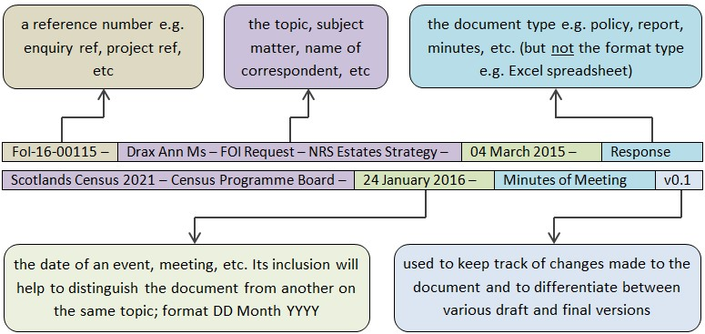

Figure No 2: Document naming conventions (Source: National Records of Scotland)

Examples

Correspondence
ICO-0249 | Letter of response from SBC to Information Commissioner (ICO) – Following appointment |  |  | 16 April 2021 |  | Response
Documents
SBC – eRDM File Plan |  | 21 July 2021 | List of folders & files |  | V 1.0

